1.Отобразить на **product-page** **выбранный** товар:

**resources\views\shop\product.blade.php**

...

<img src="**{{ asset('public/img/' . $product->image) }}**" alt="" />

...

<p class="product-price">**{{$product->price}}**</p>

...

<h6>**{{$product->name}}**</h6>

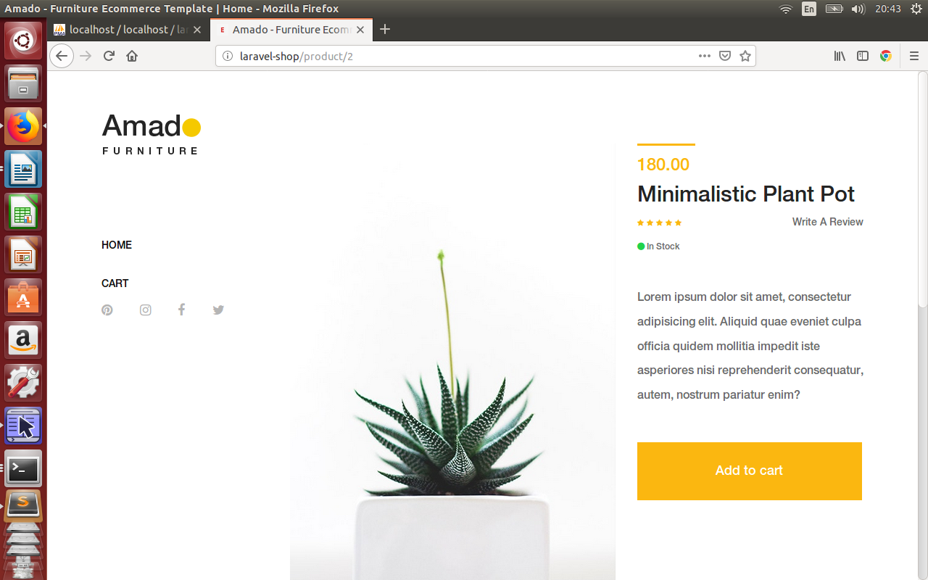

2.При **click** на **Add to cart** добавить выбранный товар в таблицу **carts** (**+redirect** на страницу **cart** (пока отображается **исходная верстка**)):

<form class="cart clearfix" **method="post" action="{{route('tocart')}}"**>

**{{ csrf_field() }}**

<input type="hidden" **name="name" value="{{$product->name}}"** />

<input type="hidden" **name="price" value="{{$product->price}}"** />

<input type="hidden" **name="image" value="{{$product->image}}"** />

<button ***type="submit"*** name="addtocart" value="5" class="btn amado-btn">Add to cart</button>

</form>

**(...or (if form is not here - js))**

**routes\web.php**

Route::**name('tocart')->post('/tocart', 'ShopController@tocart')**;

**app\Http\Controllers\ShopController.php**

/**

* Store thing to cart.

*

* @return \Illuminate\Contracts\Support\Renderable

*/

public function t**ocart(Request $request, ShopRepository $repository)**

**{**

**$repository->store($request);**

**return redirect(route('cart'));**

}

**app\Models\Cart.php**

class Cart extends Model {

public $timestamps = false;

**protected $fillable = [**

**'name', 'price', 'image'**

**];**

}

**app\Repositories\ProductRepository.php**

use App\Models\ {

Product,

**Cart**

};

…

public function **store($request)**

{

**Cart::create($request->all());**

}

